**Year 8 Half Term Assessment 2 – Micro:bit Block Editor**

**Instructions**

This assessment is in two parts. Make sure you complete both parts.

Save this document in your OneDrive. Share it with your teacher

**Part 1: Coding**

**Aim to take 15 minutes on this section**

Murphy is a new student to the school. They have never used a micro:bit before. They would like to see what it can do.

Open the **micro:bit block editor** and create a new project.

Call the project “assessment”

Using the **block editor**, create a program that will do the following:

1. When the micro:bit is **first turned on**, show the following **two** patterns in a loop that **repeats 4 times**, with a **half second pause** in between them

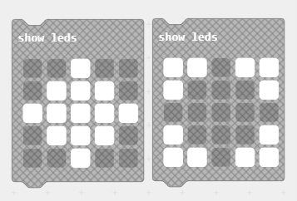

1. Once these patterns have finished, **clear the screen**
2. When **button A** is pressed: display the message “Welcome to SHS”
3. When **button B** is pressed: display an image of a smiley face for **two seconds**. The screen should then blank itself
4. When the micro:bit is **shaken**, display a random number between **1 and 20**

**Part 2: Write up**

**Aim to take about 20 minutes on this section**

Print screen the code you have produced for each step. You may need to use more than on screenshot to do this effectively.

Resize the screenshots so that your teacher can read them easily.

For each screenshot, **describe** what you have made and **explain** why you have made it that way.